

XTM Connect for Sitecore Docker v3.11

Dated: 03 November 2021

**Documentation for XTM Connect for Sitecore Docker**

**Published by XTM International Ltd.**

**© Copyright XTM International Ltd. All rights reserved. No part of this publication may be reproduced or transmitted in any form or by any means, including photocopying, without the written permission of XTM International Ltd.**

**Updated 25.11.2022**

XTM-International Ltd, Ponders, Hedgerley Lane, Gerrards Cross, SL9 8SY, UK

Tel.: +44 (0)1753 480479 email: sales@xtm.cloud [http://www.xtm.cloud](http://www.xtm-intl.com)

**Table of Contents**

Prerequisites 4

Loading the XTM Connect assets image 5

Adding XTM Connect Sitecore module 6

Importing the XTM Connect Items 11

Verifying the XTM Connect installation 12

Updating the XTM Connect 14

# Prerequisites

The basic knowledge of containers, Docker and developing Sitecore using Docker is required to successfully install the XTM Connect for Sitecore. To serialize items Sitecore Command Line Interface (CLI) in version 5.1.25 is required. More info about CLI can be found on Sitecore documentation website:

(<https://doc.sitecore.com/xp/en/developers/100/developer-tools/install-sitecore-command-line-interface.html>).

This process is very similar to adding other Sitecore modules in Docker (like Sitecore Management Services or Sitecore PowerShell Extensions).

.

# Loading the XTM Connect assets image

After downloading the *xtm-connect-sitecore-assets.tar* file call the command:

| docker load --input .\xtm-connect-sitecore-assets.tar |
| --- |

This will add a new image (*src.xtm.cloud/xtm-connect-sitecore-assets*) to the Docker Images

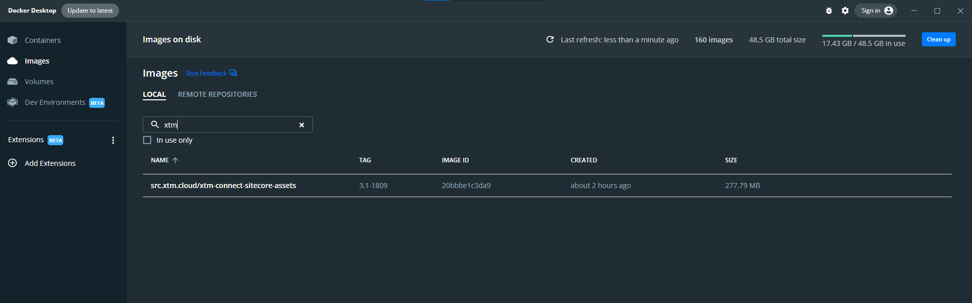

# 

# Adding XTM Connect Sitecore module

Go to *\custom-images\docker\build\cm* and open *Dockerfile* in any editor.

First declare the build image argument. eg.

| ARG XTM_CONNECT_IMAGE |
| --- |

Initiate the builder stage for the code compilation.

| FROM ${XTM_CONNECT_IMAGE} as xtm |
| --- |

Add the XTM Connect module.

| #Add Xtm Connector COPY --from=xtm \xtm_assets \inetpub\wwwroot |
| --- |

Add user rights for XTM Connect work directory

| # Access rights for XtmData folder RUN icacls 'C:\inetpub\wwwroot\XtmData\*' /grant 'IIS_IUSRS:(F)' /t |
| --- |

Dockerfile should look like:

| # escape=`  ARG BASE_IMAGE ARG SXA_IMAGE ARG SPE_IMAGE ARG TOOLING_IMAGE ARG SOLUTION_IMAGE ARG MANAGEMENT_SERVICES_IMAGE **ARG XTM_CONNECT_IMAGE** ARG HORIZON_RESOURCES_IMAGE  FROM ${SOLUTION_IMAGE} as solution FROM ${TOOLING_IMAGE} as tooling FROM ${SPE_IMAGE} as spe FROM ${SXA_IMAGE} as sxa **FROM ${XTM_CONNECT_IMAGE} as xtm** FROM ${MANAGEMENT_SERVICES_IMAGE} AS management_services FROM ${HORIZON_RESOURCES_IMAGE} as horizon_resources FROM ${BASE_IMAGE}    SHELL ["powershell", "-Command", "$ErrorActionPreference = 'Stop'; $ProgressPreference = 'SilentlyContinue';"]  # Copy development tools and entrypoint COPY --from=tooling \tools\ \tools\  WORKDIR C:\inetpub\wwwroot  # Add SPE module COPY --from=spe \module\cm\content .\  # Add SXA module COPY --from=sxa \module\cm\content .\ COPY --from=sxa \module\tools \module\tools RUN C:\module\tools\Initialize-Content.ps1 -TargetPath .\; `  Remove-Item -Path C:\module -Recurse -Force;  #Add Xtm Connector **COPY --from=xtm \xtm_assets \inetpub\wwwroot**  #Add SMS COPY --from=management_services C:\module\cm\content C:\inetpub\wwwroot  # Add horizon module COPY --from=horizon_resources \module\cm\content \inetpub\wwwroot  # Copy solution website files COPY --from=solution \artifacts\website\ .\  # Copy solution transforms COPY --from=solution \artifacts\transforms\ \transforms\solution\  # Copy role transforms COPY .\transforms\ \transforms\role\  # Perform solution transforms RUN C:\tools\scripts\Invoke-XdtTransform.ps1 -Path .\ -XdtPath C:\transforms\solution\DockerExamples.Website  # Perform role transforms RUN C:\tools\scripts\Invoke-XdtTransform.ps1 -Path .\ -XdtPath C:\transforms\role  # Access rights for XtmData folder **RUN icacls 'C:\inetpub\wwwroot\XtmData\*' /grant 'IIS_IUSRS:(F)' /t** |
| --- |

Go to *\custom-images* folder and open *docker-compose.xm1.override.yml* in editor. Navigate to cm image section and add new arg for XTM Connect module.

| XTM_CONNECT_IMAGE: ${XTM_DOCKER_REGISTRY}xtm-connect-sitecore-assets:${XTM_CONNECT_VERSION} |
| --- |

In case when more than one compose file uses *./docker/build/cm* as the build context add the arg also to those files.  
The cm compose stage can look like this:

| cm:  image: ${REGISTRY}${COMPOSE_PROJECT_NAME}-xm1-cm:${VERSION:-latest}  build:  context: ./docker/build/cm  args:  BASE_IMAGE: ${SITECORE_DOCKER_REGISTRY}sitecore-xm1-cm:${SITECORE_VERSION}  SPE_IMAGE: ${SITECORE_MODULE_REGISTRY}sitecore-spe-assets:${SPE_VERSION}  SXA_IMAGE: ${SITECORE_MODULE_REGISTRY}sitecore-sxa-xm1-assets:${SXA_VERSION}  TOOLING_IMAGE: ${SITECORE_TOOLS_REGISTRY}sitecore-docker-tools-assets:${TOOLS_VERSION}  HORIZON_RESOURCES_IMAGE: ${SITECORE_MODULE_REGISTRY}horizon-integration-xm1-assets:${HORIZON_ASSET_VERSION}  MANAGEMENT_SERVICES_IMAGE: ${SITECORE_MODULE_REGISTRY}sitecore-management-services-xm1-assets:${MANAGEMENT_SERVICES_VERSION}  **XTM_CONNECT_IMAGE: ${XTM_DOCKER_REGISTRY}xtm-connect-sitecore-assets:${XTM_CONNECT_VERSION}**  SOLUTION_IMAGE: ${REGISTRY}${COMPOSE_PROJECT_NAME}-solution:${VERSION:-latest}  depends_on:  - solution  volumes:  - ${LOCAL_DEPLOY_PATH}\website:C:\deploy  - ${LOCAL_DATA_PATH}\cm:C:\inetpub\wwwroot\App_Data\logs  environment:  SITECORE_DEVELOPMENT_PATCHES: CustomErrorsOff  Sitecore_Horizon_ClientHost: https://${HRZ_HOST}  entrypoint: powershell -Command "& C:\\tools\\entrypoints\\iis\\Development.ps1" |
| --- |

Define the XTM_DOCKER_REGISTRY and XTM_CONNECT_VERSION in .env file.

| XTM_DOCKER_REGISTRY=src.xtm.cloud/ XTM_CONNECT_VERSION=3.1-1809 |
| --- |

Example .env file

| COMPOSE_PROJECT_NAME=docker-examples REGISTRY= VERSION=  SOLR_PORT=8984 HTTPS_PORT=443 TRAEFIK_MANAGEMENT_PORT=8079 MSSQL_PORT=14330 XCONNECT_PORT=8081  SOLUTION_BUILD_IMAGE=mcr.microsoft.com/dotnet/framework/sdk:4.8 SOLUTION_BASE_IMAGE=mcr.microsoft.com/windows/nanoserver:1809 BUILD_CONFIGURATION=debug  LOCAL_DEPLOY_PATH=.\docker\deploy LOCAL_DATA_PATH=.\docker\data  CD_HOST=cd.dockerexamples.localhost CM_HOST=cm.dockerexamples.localhost ID_HOST=id.dockerexamples.localhost HRZ_HOST=hrz.dockerexamples.localhost  SITECORE_DOCKER_REGISTRY=scr.sitecore.com/sxp/ SITECORE_TOOLS_REGISTRY=scr.sitecore.com/tools/ SITECORE_MODULE_REGISTRY=scr.sitecore.com/sxp/modules/ **XTM_DOCKER_REGISTRY=src.xtm.cloud/** MANAGEMENT_SERVICES_VERSION=5.1.25-1809 SITECORE_VERSION=10.2-ltsc2019 TOOLS_VERSION=10.2-1809 SPE_VERSION=6.3-1809 SXA_VERSION=10.2-1809 HORIZON_VERSION=3.0-ltsc2019 HORIZON_ASSET_VERSION=3.0-1809 **XTM_CONNECT_VERSION=3.1-1809**  **…** |
| --- |

Now you are ready to build the containers using *docker-compose build* command and run them using *docker-compose up*.

# Importing the XTM Connect Items

Download the *XTM.Connect.Sitecore.3.1.itempackage* file to your docker base work directory (e.g. *\custom-images*) and use CLI (in version 5.1.25) to your Sitecore instance by calling:

| dotnet sitecore ser pkg install -f XTM.Connect.Sitecore.3.1.itempackage |
| --- |

CLI Sitecore Content Serialization (SCS) packages (*.itempackage* files) can be used in your delivery pipeline. More info here:

<https://doc.sitecore.com/xp/en/developers/100/developer-tools/create-and-install-a-sitecore-content-serialization-package.html>

It is also possible to install the required Sitecore items without CLI. Download *XTM Connect for Sitecore Items only-3.11.1300.0901.zip* package and install it using *Development Tools -> Installation Wizard* in your Sitecore Desktop app.

# 

# Verifying the XTM Connect installation

Login to your cm instance (e.g. <https://cm.dockerexamples.localhost/sitecore>) navigate to Content Editor. There should be a new XTM Ribbon tab, XTM Connect item under Content, new templates, workflows and roles. Now you are ready to setup the XTM Connect Settings and start using the XTM Connect for Sitecore. For more information check the Documentation item under XTM Ribbon tab.

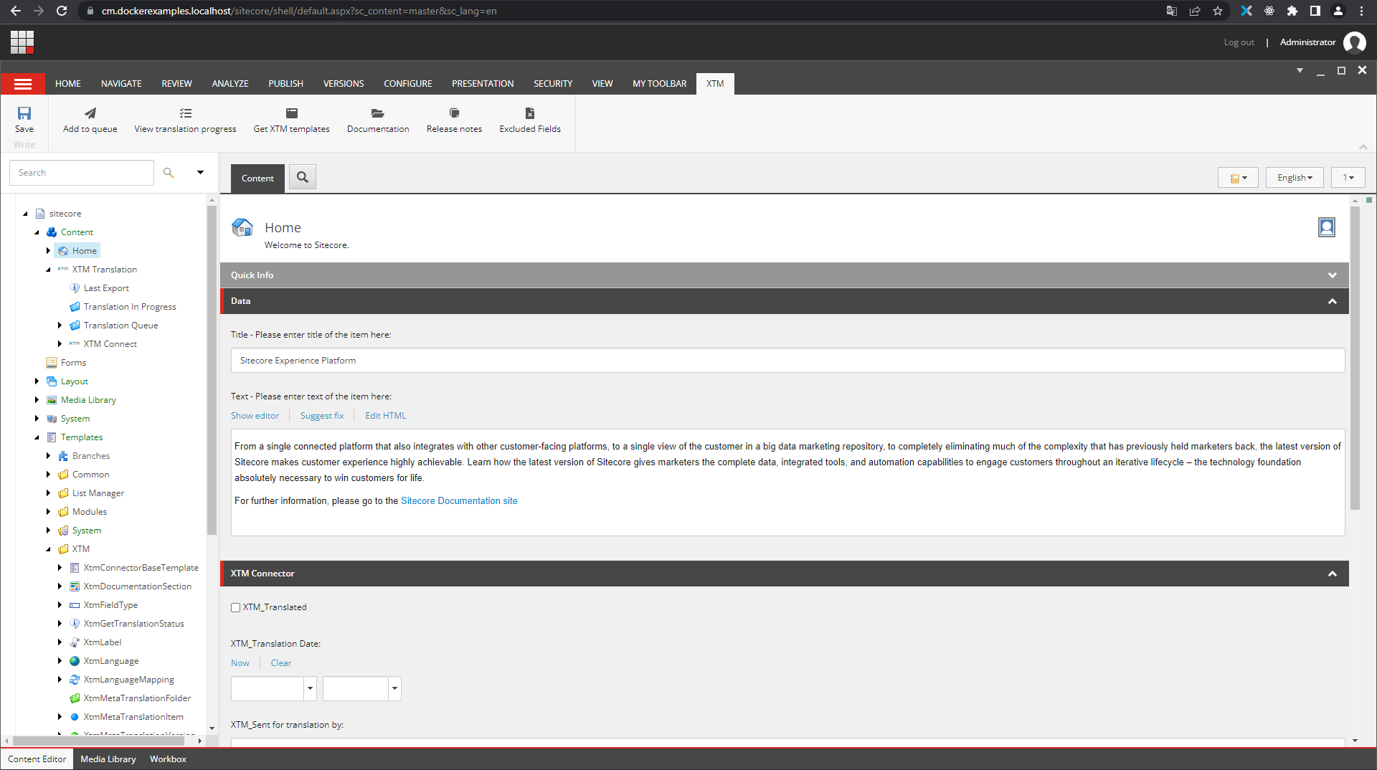

# Updating the XTM Connect

When a new version of XTM Connect is released you can just modify the *XTM_CONNECT_VERSION* variable in the *.env* file, rebuild your containers and resync the XTM Connect Sitecore items using CLI.



[**https://xtm.cloud**](https://xtm.cloud/)